Internet Gateway

🌐 What is an Internet Gateway?
# Source: AI Source: Provided by: [Data Path: Persons Table -> ID Column: 1, Name_En Column: Motasem Essam] -> From: [ChatGPT] on [12/18/2025]
An Internet Gateway is a network component (physical or virtual) that allows devices in a private network to access the internet and also receive connections from the internet (if allowed). It acts as the bridge between your internal network and the global internet.
✅ It’s like the front door that connects your private network to the public internet.

🔧 What It Does
# Source: AI Source: Provided by: [Data Path: Persons Table -> ID Column: 1, Name_En Column: Motasem Essam] -> From: [ChatGPT] on [12/18/2025]
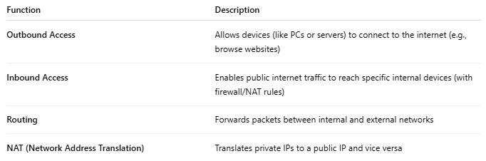

Function | Description
Outbound Access | Allows devices (like PCs or servers) to connect to the internet (e.g., browse websites)
Inbound Access | Enables public internet traffic to reach specific internal devices (with firewall/NAT rules)
Routing | Forwards packets between internal and external networks
NAT (Network Address Translation) | Translates private IPs to a public IP and vice versa

🏠 Example: Home Network
# Source: AI Source: Provided by: [Data Path: Persons Table -> ID Column: 1, Name_En Column: Motasem Essam] -> From: [ChatGPT] on [12/18/2025]
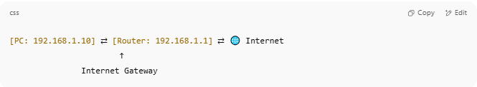
[PC: 192.168.1.10] ⇄ [Router: 192.168.1.1] ⇄ 🌐 Internet
↑
Internet Gateway

- Your home router acts as an internet gateway by:
  - Sending traffic from your devices to the internet
  - Receiving responses from websites and delivering them to the right device

☁️ Example: Cloud Platform (AWS)
# Source: AI Source: Provided by: [Data Path: Persons Table -> ID Column: 1, Name_En Column: Motasem Essam] -> From: [ChatGPT] on [12/18/2025]
In cloud services (like AWS), an Internet Gateway (IGW) is a virtual device that:
- Connects a VPC (Virtual Private Cloud) to the internet
- Enables public subnets (e.g., a web server) to be reachable from outside
- Is attached at the VPC level, not to specific instances
🔐 IGWs work with route tables, public IPs, and security groups to define access.

🧠 Internet Gateway vs Other Gateways
# Source: AI Source: Provided by: [Data Path: Persons Table -> ID Column: 1, Name_En Column: Motasem Essam] -> From: [ChatGPT] on [12/18/2025]
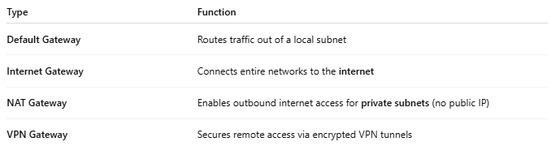

Type | Function
Default Gateway | Routes traffic out of a local subnet
Internet Gateway | Connects entire networks to the internet
NAT Gateway | Enables outbound internet access for private subnets (no public IP)
VPN Gateway | Secures remote access via encrypted VPN tunnels

✅ Pros
# Source: AI Source: Provided by: [Data Path: Persons Table -> ID Column: 1, Name_En Column: Motasem Essam] -> From: [ChatGPT] on [12/18/2025]
- ✅ Enables full internet access for private networks
- ✅ Allows public access to apps like web servers
- ✅ Essential for cloud deployments
- ✅ Works with routing, firewall, and NAT policies for control

❌ Cons
# Source: AI Source: Provided by: [Data Path: Persons Table -> ID Column: 1, Name_En Column: Motasem Essam] -> From: [ChatGPT] on [12/18/2025]
- ❌ Public exposure increases security risk
- ❌ Requires proper firewall/NAT settings to avoid vulnerabilities
- ❌ In cloud, extra costs may apply for traffic through gateways

📌 Summary
# Source: AI Source: Provided by: [Data Path: Persons Table -> ID Column: 1, Name_En Column: Motasem Essam] -> From: [ChatGPT] on [12/18/2025]
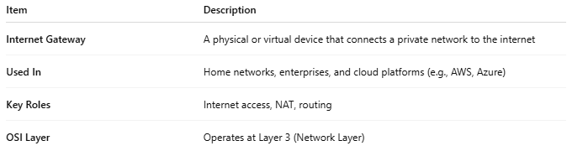

Item | Description
Internet Gateway | A physical or virtual device that connects a private network to the internet
Used In | Home networks, enterprises, and cloud platforms (e.g., AWS, Azure)
Key Roles | Internet access, NAT, routing
OSI Layer | Operates at Layer 3 (Network Layer)

